**Madera South High School**

**2023 Cross Country Schedule**

**DAY DATE MEET SITE TIME Release B/V Depart Return** 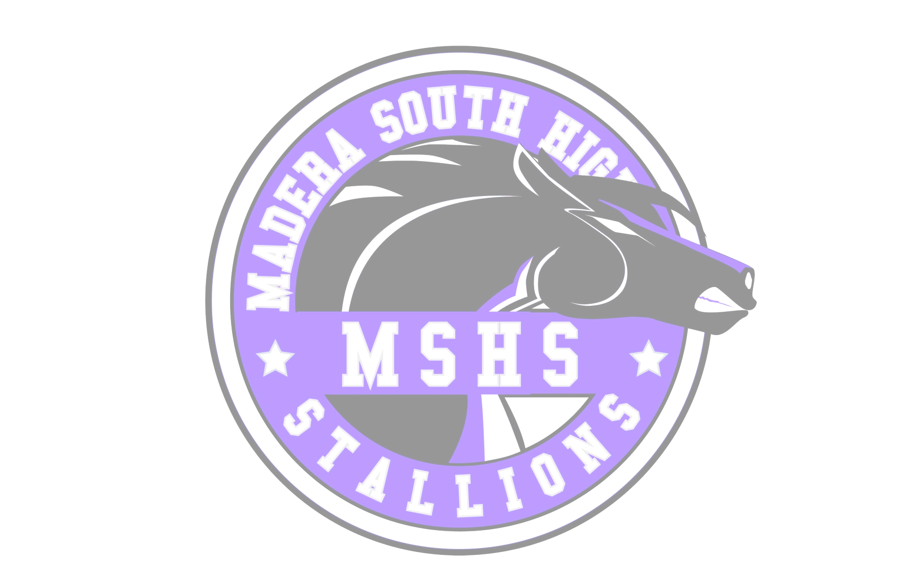

Saturday August 12 Fleet Feet Summer Sizzle Woodward Park 7:30am B 5:45am 12pm

**Saturday August 26 Dennis Dewitt Invitational MSHS Campus 8:00am**

Saturday September 9 Morro Bay Invitational Morro Bay HS 9:30am B 5:00am 7pm

Friday* September 15-16 *Woodbridge Invitational* Orange County Great Park TBD 3V 8am TBD

Friday September 22 Golden Eagle Invitational Woodward Park 3:30pm 1pm B 1:30pm 7:30pm

Saturday October 7 Asics Clovis Invitational Woodward Park 9:50am B 7am 6pm

Friday October 20 Clovis North Twilight Meet Clovis North 6:00pm 3pm B 3:30pm 12am

Friday October 27 Clovis East Invitational Clovis East HS 3: 30pm 1pm B 1:30pm 7:30pm

Wednesday November 1 Central Valley JV Championships Woodward Park 2:30pm 12pm B 12:30pm 5pm

Tuesday November 7 NYL Championships Woodward Park 1:00pm 11am B 11:20am 6pm

Thursday November 16 Valley Championships Woodward Park TBA 9:30am 3V 10am 8pm

Saturday November 25 State Championships Woodward Park TBA N/A 3V 7am 8pm

Saturday* December 3 *NXN Chamionships Glendoveer Golf Course, OR TBA TBD TBD

Schedule is subject to change: based on needs of the team, transportation and meet hosts

* = Possible overnight trip, pending: board approval, funds and team acceptance into meet

**BOLD** = meet we host

Principal: Mr. Jon Steinmentz

Athletic Director: Andrea Devine

Co-Head Coach: Sky Fierro, Benny Madrigal

Colors: Purple, Silver, Black

Mascot: Stallions